**Linux File System**

Operating systems, the software that powers your computer, rely on a crucial element known as the file system. Think of it as a virtual organizational tool that manages, stores, and retrieves your data efficiently. In the Linux world, a diverse range of file systems has emerged, each crafted to address specific needs and preferences.

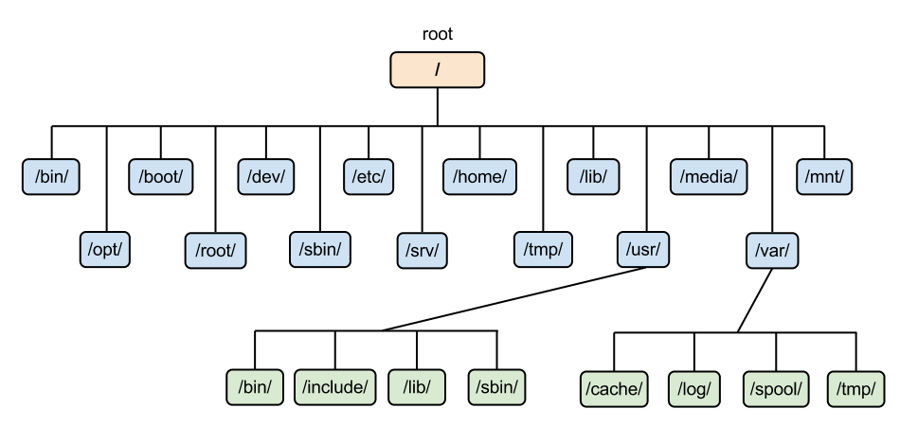

1. Linux File system hierarchy

The Linux file system is a multifaceted structure comprised of three essential layers. At its foundation, the Logical File System serves as the interface between user applications and the file system, managing operations like opening, reading, and closing files. Above this, the Virtual File System facilitates the concurrent operation of multiple physical file systems, providing a standardized interface for compatibility. Finally, the Physical File System is responsible for the tangible management and storage of physical memory blocks on the disk, ensuring efficient data allocation and retrieval. Together, these layers form a cohesive architecture, orchestrating the organized and efficient handling of data in the Linux operating system.

**Linux File System Structure**

A file system mainly consists of 3 layers. From top to bottom:

**1. Logical File System:**

The Logical File System acts as the interface between the user applications and the file system itself. It facilitates essential operations such as opening, reading, and closing files. Essentially, it serves as the user-friendly front-end, ensuring that applications can interact with the file system in a way that aligns with user expectations.

**2. Virtual File System:**

The Virtual File System (VFS) is a crucial layer that enables the concurrent operation of multiple instances of physical file systems. It provides a standardized interface, allowing different file systems to coexist and operate simultaneously. This layer abstracts the underlying complexities, ensuring compatibility and cohesion between various file system implementations.

**3. Physical File System:**

The Physical File System is responsible for the tangible management and storage of physical memory blocks on the disk. It handles the low-level details of storing and retrieving data, interacting directly with the hardware components. This layer ensures the efficient allocation and utilization of physical storage resources, contributing to the overall performance and reliability of the file system.

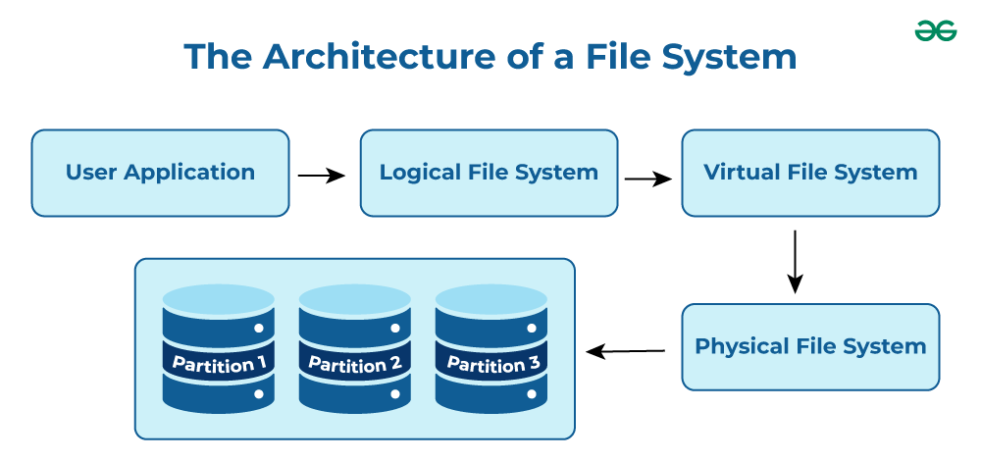

1. Architecture of Linux file system

**Characteristics of a File System**

* **Space Management**: how the data is stored on a storage device. Pertaining to the memory blocks and fragmentation practices applied in it.
* **Filename**: a file system may have certain restrictions to file names such as the name length, the use of special characters, and case sensitive-ness.
* **Directory**: the directories/folders may store files in a linear or hierarchical manner while maintaining an index table of all the files contained in that directory or subdirectory.
* **Metadata**: for each file stored, the file system stores various information about that file’s existence such as its data length, its access permissions, device type, modified date-time, and other attributes. This is called metadata.
* **Utilities**: file systems provide features for initializing, deleting, renaming, moving, copying, backup, recovery, and control access of files and folders.
* **Design**: due to their implementations, file systems have limitations on the amount of data they can store.

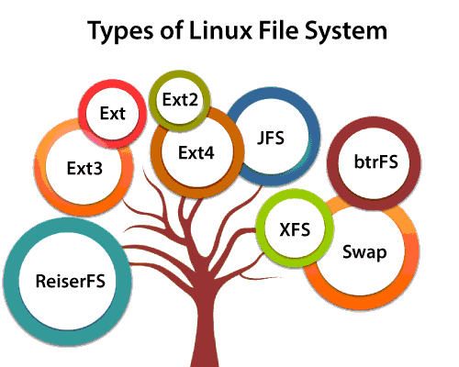

Following are some very short standard, defined, and well-known top-level Linux directory list and their purposes:

* **/ (root filesystem):** It is the top-level filesystem directory. It must include every file needed to boot the Linux system before another filesystem is mounted. Every other filesystem is mounted on a well-defined and standard mount point because of the root filesystem directories after the system is started.
* **/boot:** It includes the static kernel and bootloader configuration and executable files needed to start a Linux computer.
* **/bin:** This directory includes user executable files.
* **/dev:** It includes the device file for all hardware devices connected to the system. These aren't device drivers; instead, they are files that indicate all devices on the system and provide access to these devices.
* **/etc:** It includes the local system configuration files for the host system.
* **/lib:** It includes shared library files that are needed to start the system.
* **/home:** The home directory storage is available for user files. All users have a subdirectory inside /home.
* **/mnt:** It is a temporary mount point for basic filesystems that can be used at the time when the administrator is working or repairing a filesystem.
* **/media:** A place for mounting external removable media devices like USB thumb drives that might be linked to the host.
* **/opt:** It contains optional files like vendor supplied application programs that must be placed here.
* **/root:** It's the home directory for a root user. Keep in mind that it's not the '/' (root) file system.
* **/tmp:** It is a temporary directory used by the OS and several programs for storing temporary files. Also, users may temporarily store files here. Remember that files may be removed without prior notice at any time in this directory.
* **/sbin:** These are system binary files. They are executables utilized for system administration.
* **/usr:** They are read-only and shareable files, including executable libraries and binaries, man files, and several documentation types.
* **/var:** Here, variable data files are saved. It can contain things such as MySQL, log files, other database files, email inboxes, web server data files, and much more.